How India voted in 2019?



**__________________________________________________________________________________**

**Amani K V Atharva Srivastava**

# Elections in India

They are conducted by the Election Commission which is a federal body, enacted under the provisions of the Constitution, responsible for monitoring and administering all the electoral processes of India.

A total of **8040** contested for **543**  parliamentary constituencies pan India. Major national parties competing were **UPA** and **NDA.**

## Digging into Data

Considering the massive mandate of the bygone elections, we have chosen to perform an **EDA**(Exploratory Data Analysis) using the [Lok Sabha Election Dataset](https://www.kaggle.com/prakrutchauhan/indian-candidates-for-general-election-2019).

This dataset provides information of candidates securing **more than 1%** of the total votes cast in their respective constituencies.

It consists of 2263 rows and 19 columns from which we are using 14 for analysing the data.

## Data Analysis

It was seen that over **2018 candidates** contested in the elections with ages ranging from

**25 to 86** averaging about 52 years. It was seen that there were **no null** values and **20** **unavailable** values for candidates’ assets, criminal cases and education in the dataset. These are the following observations drawn from the data -

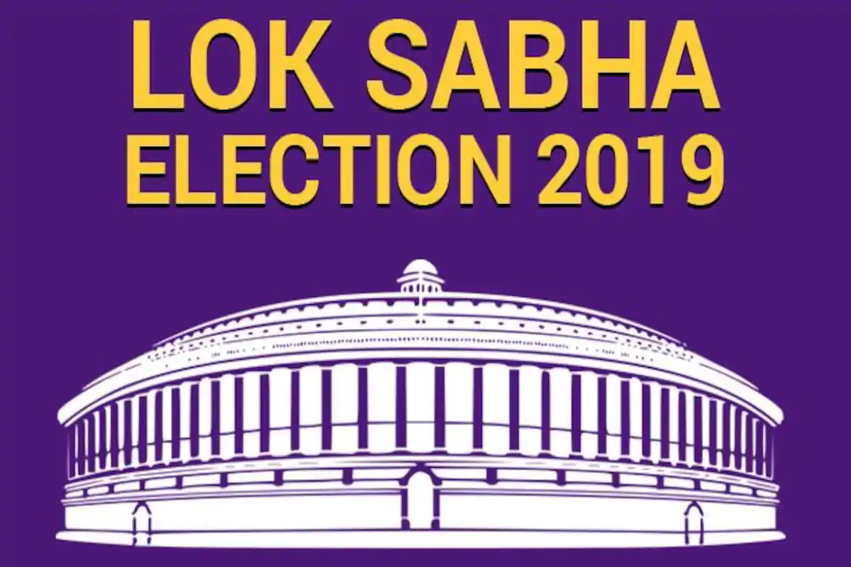

***NOTE - All the graphs, charts and maps are interactive. Please feel free to click them.***

### Constituencies -

It was observed that **Uttar Pradesh** has the highest number of constituencies from the 29 states and 7 Union Territories, having **80** constituencies of 543, it accounts for 15% of the total constituency share.

[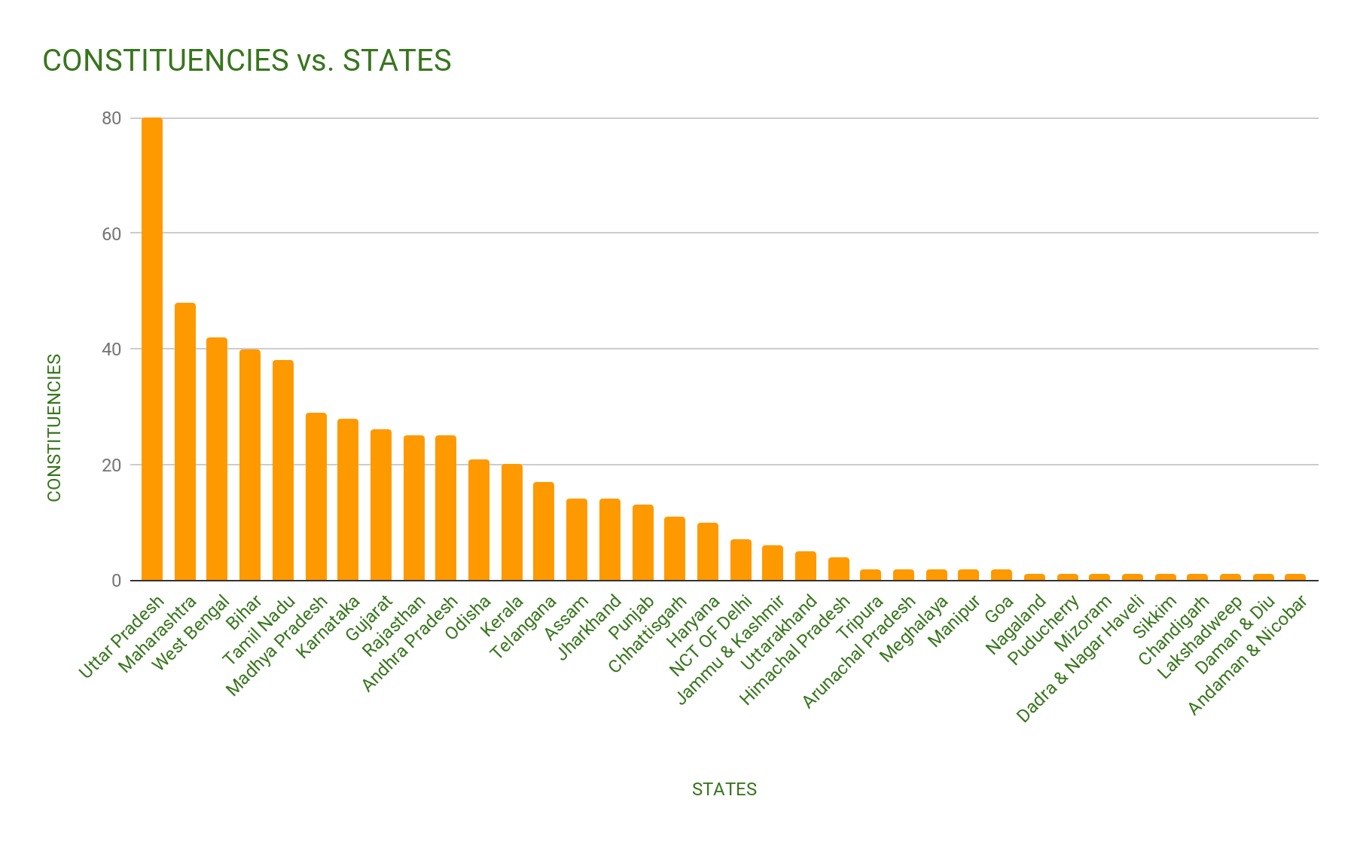](https://docs.google.com/spreadsheets/d/e/2PACX-1vTBSiGLy44YpGmmTvCrq0o3FvvhjcBW2EcrA1RsnhNftbTgtJsfo6o7kuM7WDxq4utyPm9459-iDjnh/pubchart?oid=831035767&format=interactive)

### NOTA-

This category represents the disapproval of the candidates in a voting system. **Tamil Nadu** got the **highest** number of NOTA votes.

Although **NOTA** has never exceeded the winning party votes, the highest NOTA votes were for **Gopalganj (Bihar)** amounting to **2.8 %** of the total votes.

[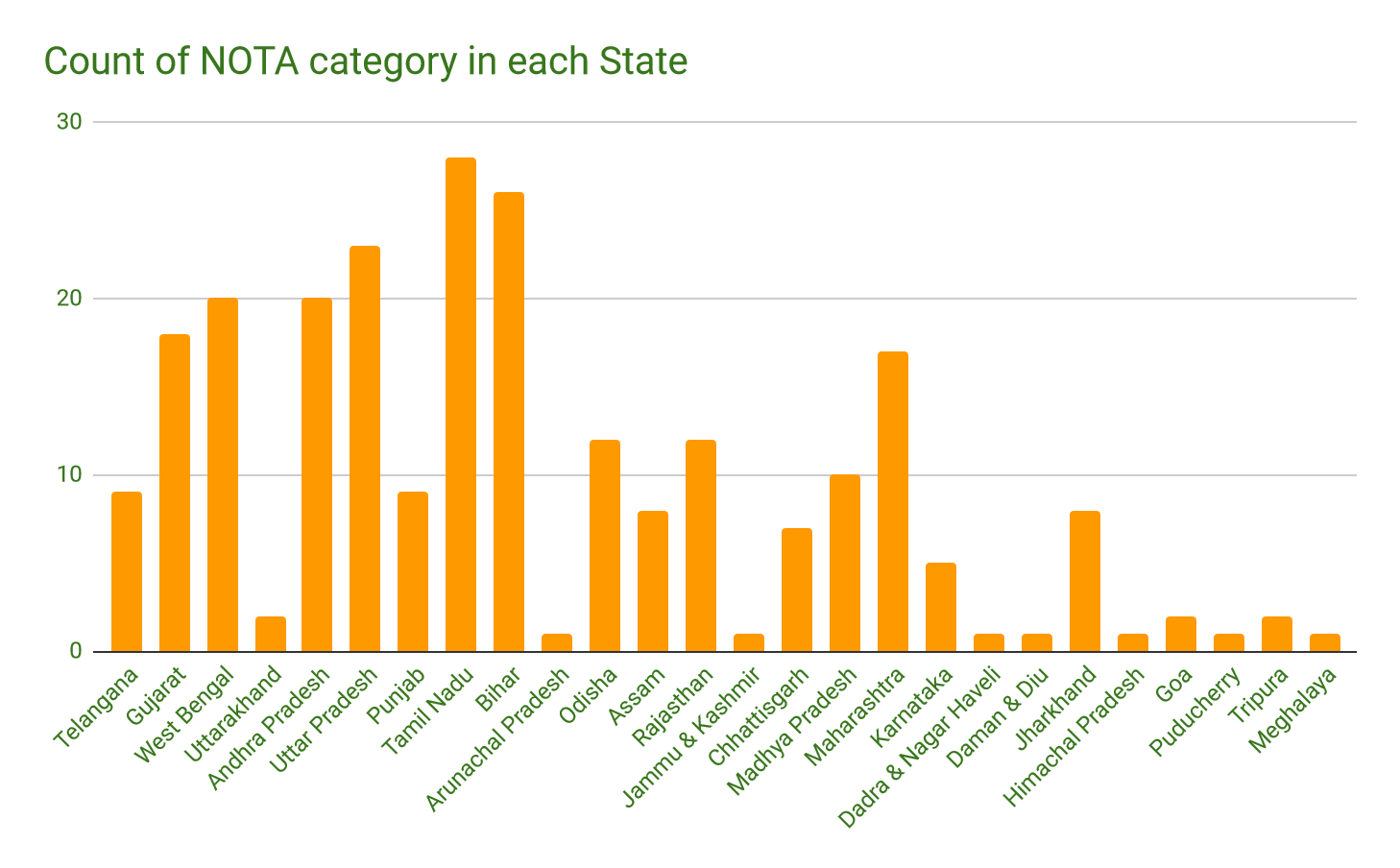](https://docs.google.com/spreadsheets/d/e/2PACX-1vTBSiGLy44YpGmmTvCrq0o3FvvhjcBW2EcrA1RsnhNftbTgtJsfo6o7kuM7WDxq4utyPm9459-iDjnh/pubchart?oid=2014984472&format=interactive)

### Candidates by Party-

**420** candidates were from **BJP(NDA)** accounting to **21%** of the total candidates. **INC** accounted for the **2nd** largest candidate share of **20%**. The rest comprises regional parties.

[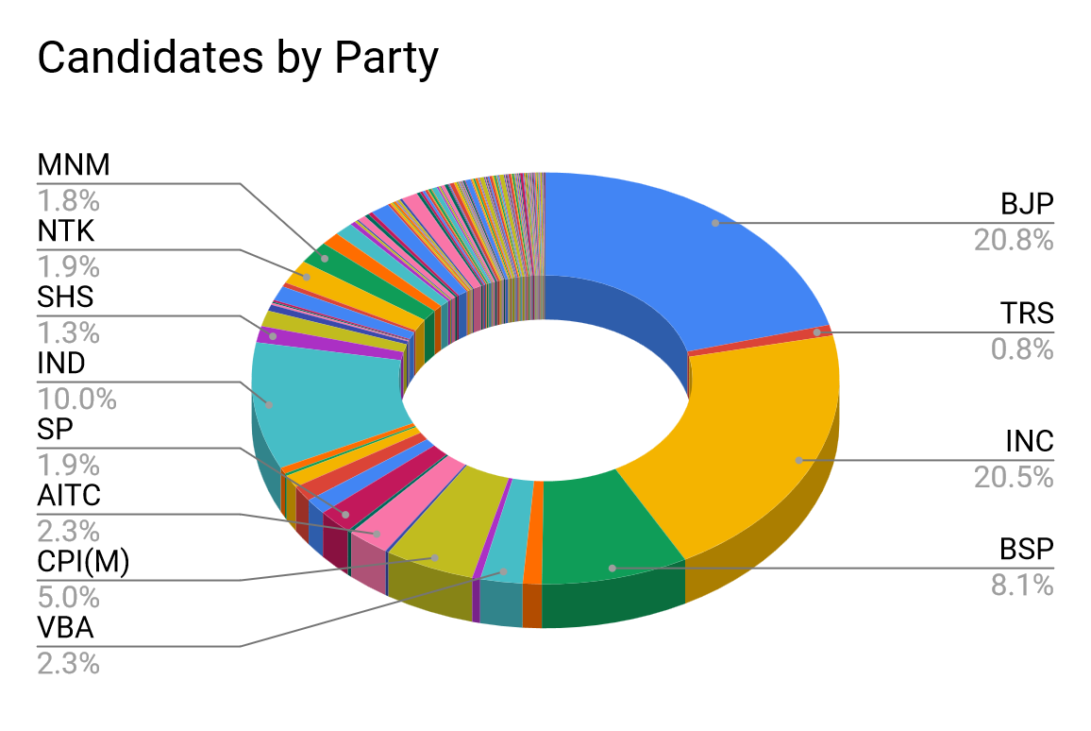](https://docs.google.com/spreadsheets/d/e/2PACX-1vTBSiGLy44YpGmmTvCrq0o3FvvhjcBW2EcrA1RsnhNftbTgtJsfo6o7kuM7WDxq4utyPm9459-iDjnh/pubchart?oid=1197606921&format=interactive)

**BJP** won the elections with **55.7%** attaining **300** seats in a clear majority.

**INC** came close to **10%** securing only **52** seats.

[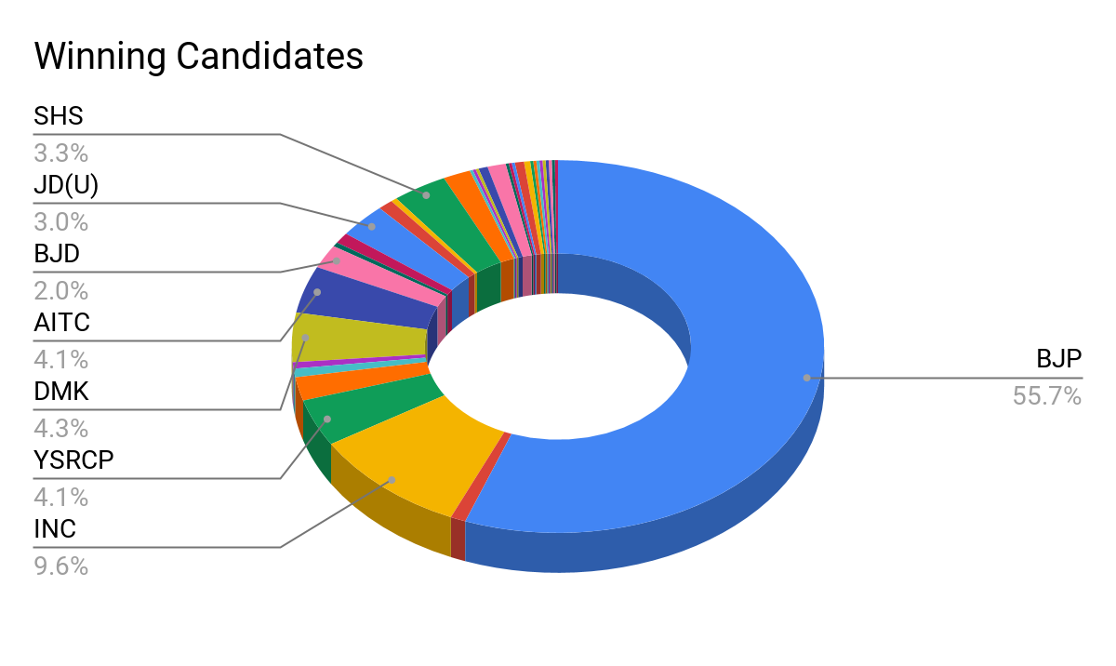](https://docs.google.com/spreadsheets/d/e/2PACX-1vTBSiGLy44YpGmmTvCrq0o3FvvhjcBW2EcrA1RsnhNftbTgtJsfo6o7kuM7WDxq4utyPm9459-iDjnh/pubchart?oid=675203457&format=interactive)

### Gender-

The maximum number of candidates(participating & winning) were **Male** whereas **Females** accounted for only about **14%**.

[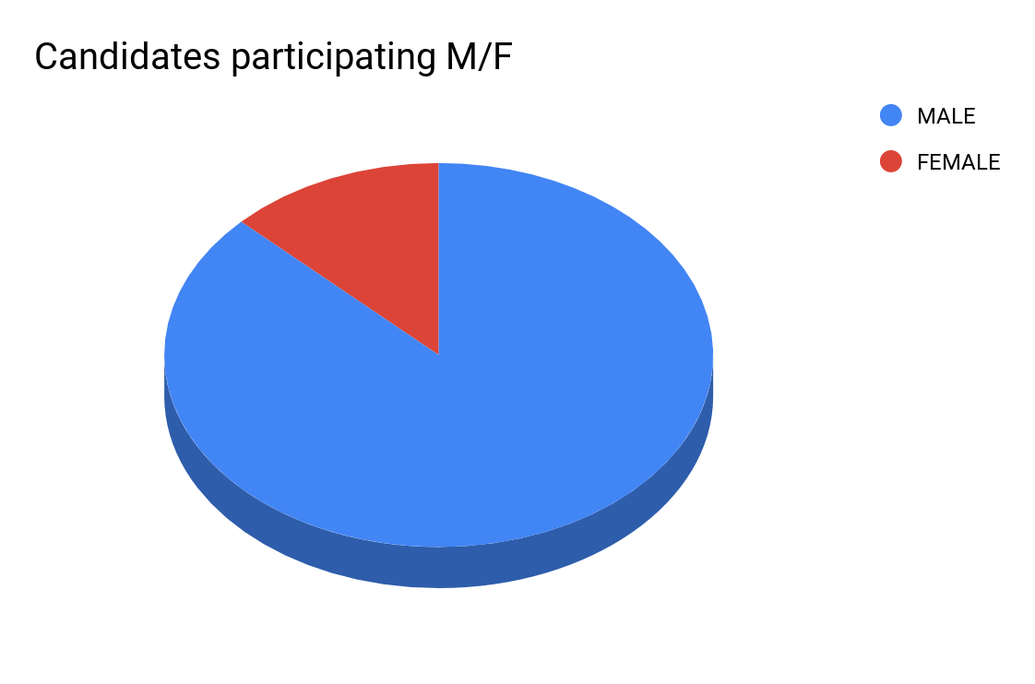](https://docs.google.com/spreadsheets/d/e/2PACX-1vTBSiGLy44YpGmmTvCrq0o3FvvhjcBW2EcrA1RsnhNftbTgtJsfo6o7kuM7WDxq4utyPm9459-iDjnh/pubchart?oid=391754336&format=interactive) [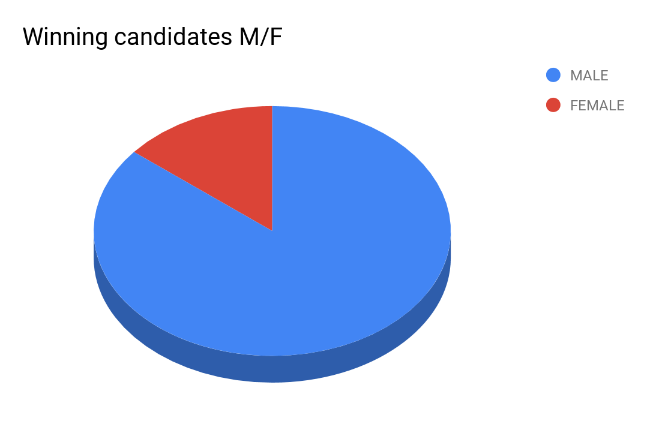](https://docs.google.com/spreadsheets/d/e/2PACX-1vTBSiGLy44YpGmmTvCrq0o3FvvhjcBW2EcrA1RsnhNftbTgtJsfo6o7kuM7WDxq4utyPm9459-iDjnh/pubchart?oid=602607250&format=interactive)

### Age -

**Maximum** age of the winning candidate is **86** and the **youngest** to win was just **26**. The **average** age is **54** years.

[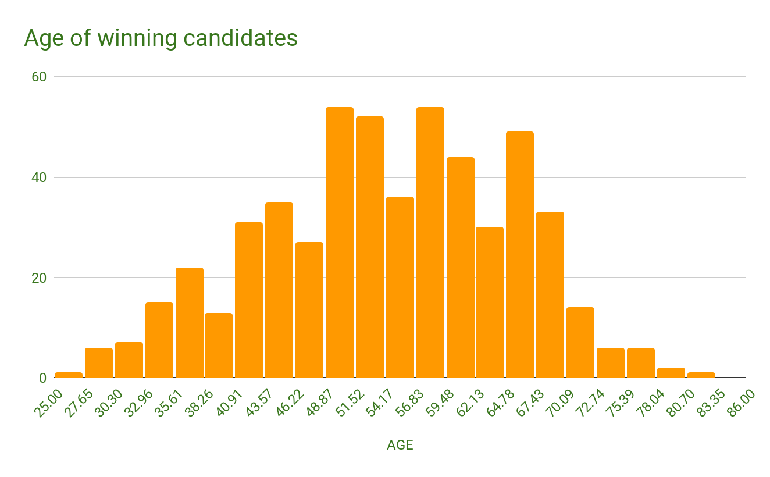](https://docs.google.com/spreadsheets/d/e/2PACX-1vTBSiGLy44YpGmmTvCrq0o3FvvhjcBW2EcrA1RsnhNftbTgtJsfo6o7kuM7WDxq4utyPm9459-iDjnh/pubchart?oid=628999455&format=interactive)

### Literacy-

More than **75%** of candidates who have won have **completed graduation.** **15%** of candidates have **won** the elections despite **not passing class 12**.

[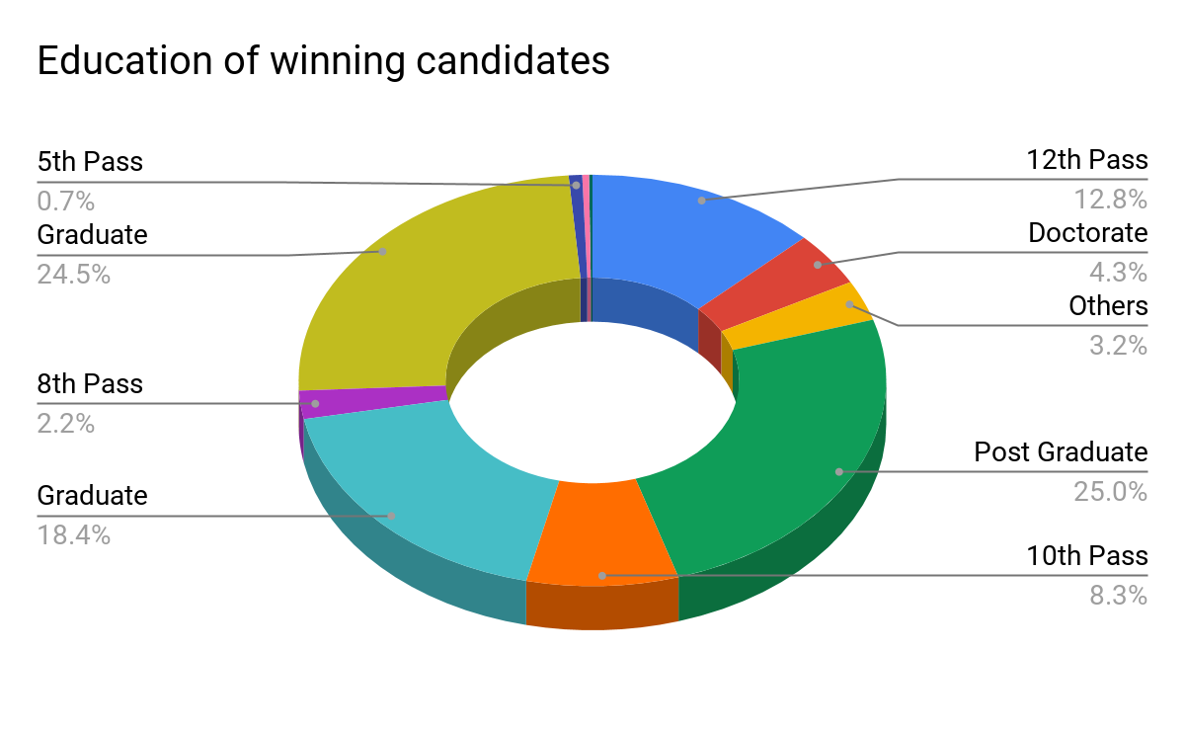](https://docs.google.com/spreadsheets/d/e/2PACX-1vTBSiGLy44YpGmmTvCrq0o3FvvhjcBW2EcrA1RsnhNftbTgtJsfo6o7kuM7WDxq4utyPm9459-iDjnh/pubchart?oid=511539943&format=interactive)

### Criminal Cases -

Out of **543** winning candidates, **43% (234)** had a criminal case registered against them.

[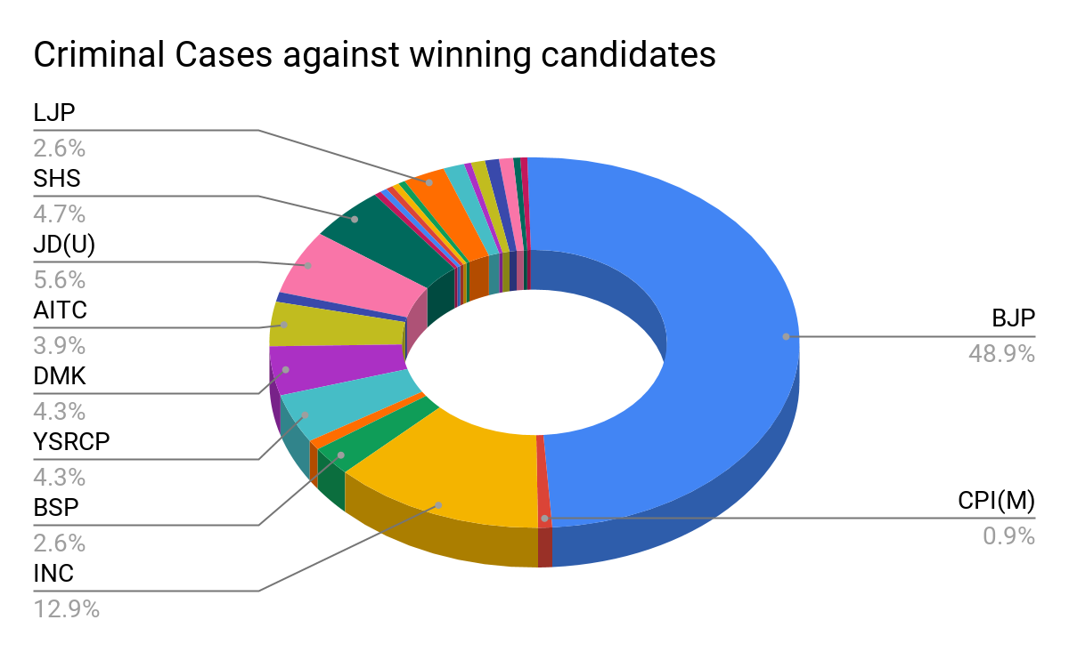](https://docs.google.com/spreadsheets/d/e/2PACX-1vTBSiGLy44YpGmmTvCrq0o3FvvhjcBW2EcrA1RsnhNftbTgtJsfo6o7kuM7WDxq4utyPm9459-iDjnh/pubchart?oid=385670598&format=interactive)

### Assets-

**70%** of candidates had assets worth **more than a crore**. The **average** assets for **participating** candidates were around **13 crores** and for the **winning** candidates, it was **21 crores**.

[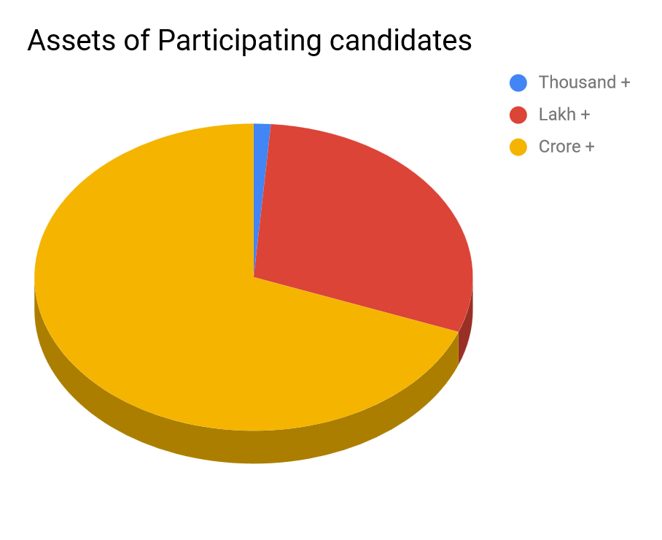](https://docs.google.com/spreadsheets/d/e/2PACX-1vTBSiGLy44YpGmmTvCrq0o3FvvhjcBW2EcrA1RsnhNftbTgtJsfo6o7kuM7WDxq4utyPm9459-iDjnh/pubchart?oid=858603589&format=interactive)[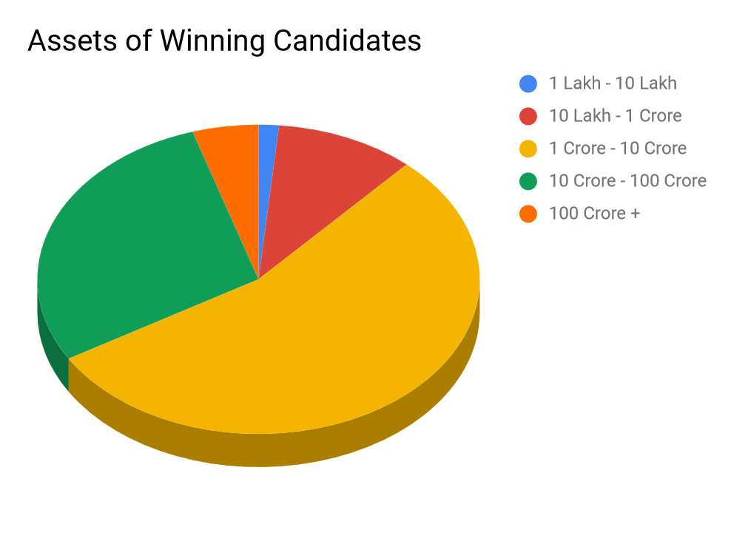](https://docs.google.com/spreadsheets/d/e/2PACX-1vTBSiGLy44YpGmmTvCrq0o3FvvhjcBW2EcrA1RsnhNftbTgtJsfo6o7kuM7WDxq4utyPm9459-iDjnh/pubchart?oid=400026914&format=interactive)

### Category(Gen/SC/ST)-

It was observed that the **maximum** number of people participated from the **general** category and the **minority candidates** participating were **626.**

[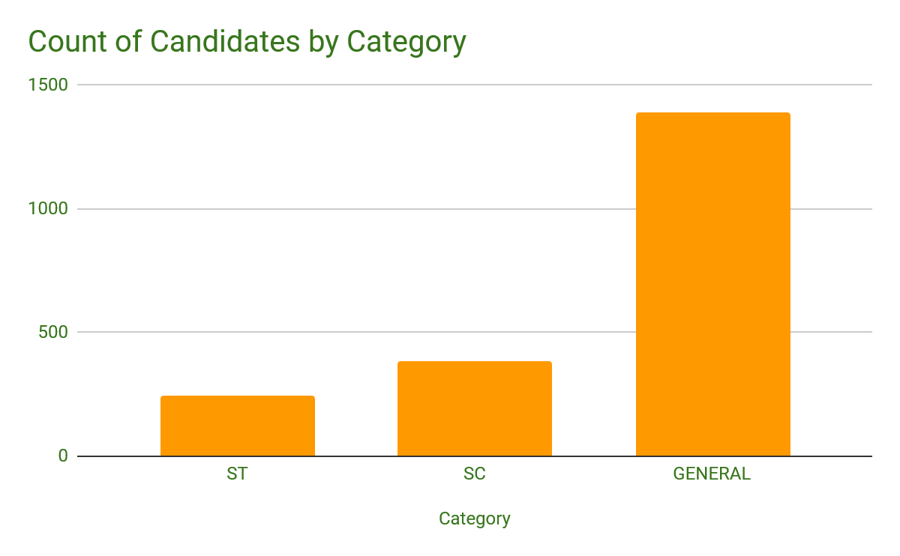](https://docs.google.com/spreadsheets/d/e/2PACX-1vTBSiGLy44YpGmmTvCrq0o3FvvhjcBW2EcrA1RsnhNftbTgtJsfo6o7kuM7WDxq4utyPm9459-iDjnh/pubchart?oid=133827124&format=interactive)

*Similarly winning candidates by Category -

**General : 399 SC : 85 ST : 55**

### Voters by State-

Uttar Pradesh had the **maximum** number of voters for its **80** constituencies, whereas the **North-Eastern** States had the **least** voters.

[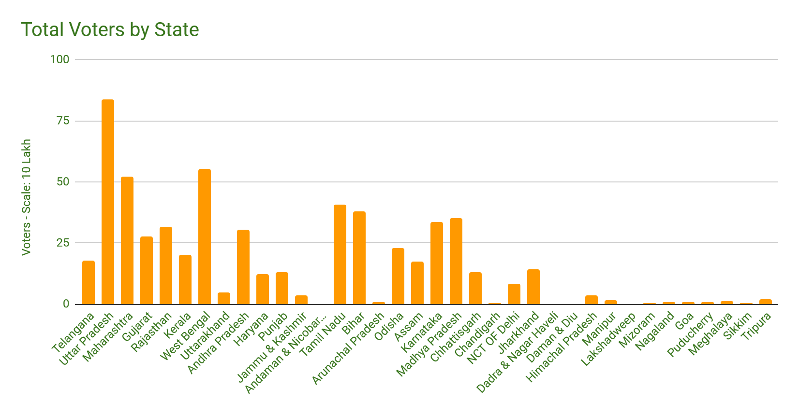](https://docs.google.com/spreadsheets/d/e/2PACX-1vTBSiGLy44YpGmmTvCrq0o3FvvhjcBW2EcrA1RsnhNftbTgtJsfo6o7kuM7WDxq4utyPm9459-iDjnh/pubchart?oid=174177743&format=interactive)

### 

### Conclusion

From the above data insights, we can observe that there are several prevalent factors that have played a prime role in determining the results of General elections- 2019.

We have made visual representations of the figures in 10 different aspects ranging from age, gender, education to declared assets of the contestants and also the contribution of the voters .